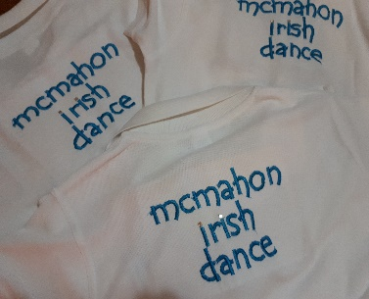

McMahon Irish Dance 2020 Timetable

CLASSES | CLASS TIMES | LOCATION
SENIOR SCHOOL  TUESDAY  WEDNESDAY  SATURDAY | 6-7PM  6.30-7.30PM  3-4.30PM NEW TIME | BROOKVALE  MOSMAN  MOSMAN
JUNIOR SCHOOL  TUESDAY  WEDNESDAY  SATURDAY | 6-7PM  6.30-7.30PM  3-4.30PM NEW TIME | BROOKVALE  MOSMAN  MOSMAN
GRADE EXAM PREP CLASS  WEDNESDAY  SATURDAY | 7.30-8PM  4.30-5PM | MOSMAN  MOSMAN
MOSMAN  STUDIO 5  MOSMAN DANCE ACADEMY  21-23 BEST AVENUE MOSMAN | BROOKVALE  BROOKVALE SCOUT HALL  51 WINBOURNE ROAD  BROOKVALE
JUNIOR SCHOOL SENIOR SCHOOL
Dancers are 4 – 12 years Dancers are 13 & over
ann.p.podolanko@bigpond.com
www.annppodolanko.wix.site/mcmahonirishdance
@ Scoil Rince MacMatuna
scoilrincemacmatuna
0418 209 496

