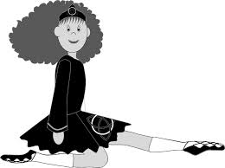
McMahon School New Dancer Enrolment 2020

Dancer name_____________________________________________
Address___________________________________________________
___________________________________________ Pcode__________
Telephone_____________________ Mobile____________________
Email______________________________________________________
Parent/Guardian/Emergency contact details
Name___________________________________________________
Telephone_____________________ Mobile__________________
AGE AS AT JAN 1 2020_______ D.O.B_____________________

Enrolling at: Brookvale_____ Mosman WED______
Mosman WED JUNIOR_____ Mosman SAT_____

Do you have any objection to the School using your image either on line or in print? YES_____ NO_____

Post to: Miss Ann email to: ann.p.podolanko@bigpond.com
McMahon School
1/14-16 Eric Street
Eastwood NSW 2122

