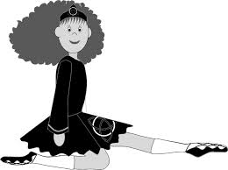 2022 Trial Class Booking

Dancer name:
Dancer age:
Parent/Guardian/Carer name:
Parent/Guardian/Carer
Parent/Guardian/Carer
Dancer (over 16)
Dancer (over 16)

my trial class will be taken
@Brookvale Tuesday___
@Mosman seniors Wednesday___
@Mosman juniors Saturday____

Return your completed Registration to Miss Ann
- ann.p.podolanko@bigpond.com
McMahon School
1/14-16 Eric Street
Eastwood NSW 2122

